CS6008 — Network Security

Building a Secure Chat Application — Final Report
This report documents the design, implementation, and verification of a chat application hardened across five incremental phases: baseline plaintext relay, Diffie-Hellman key exchange with AES-GCM encryption, PKI-based server authentication, end-to-end encryption between clients, and forward secrecy via automatic key rotation. Each cryptographic phase is accompanied by an attack demonstrating the specific threat it defeats.

Group No: 26
Name : Jay Sonawane
Roll No: 24M0818
Name: Priyanshi Saxena
Roll No: 26M0744

Table of Contents
Building a Secure Chat Application — Final Report 1
Table of Contents 1
VM Topology 1
Phase 1 — Baseline Chat Application (No Security) 1
Implementation Summary 1
Framing scheme 1
Registration 1
Command interface (spec §1.3) 1
Routing beyond 2 clients 1
Verification 1
Server-side plaintext logging 1
Wireshark capture 1
Phase 2 — Client-Server Confidentiality via Diffie–Hellman 1
Implementation Summary 1
Modular exponentiation clarification (per TA guidance) 1
Why the raw shared secret is hashed before use as a key 1
Fixed-length secret encoding 1
AES-GCM encryption 1
Nonce construction 1
Verification 1
Fingerprint matching 1
Wireshark re-capture 1
Tamper-detection test 1
MITM Attack (spec §3.3) 1
What was built 1
Result 1
Why the victim could not detect this from inside the protocol 1
Phase 3 — Server Authentication via PKI 1
Implementation Summary 1
CA setup commands (from setup_ca.sh) 1
Protocol change 1
Proof-of-possession 1
Verification 1
Legitimate flow 1
MITM re-attempt (spec §4.2) 1
Stolen certificate without the private key (separate test, spec §4.2) 1
Note on PKI's fundamental limits (discussion point) 1
Phase 4 — End-to-End Encryption Between Clients 1
Implementation Summary 1
Wire tags (spec §1.4, exact strings as required) 1
Layering 1
Nonce safety for the E2E layer 1
Protocol-level distinction between handshake and chat 1
Verification 1
Fingerprint matching, independent of the server 1
Server-blindness, before vs. after 1
Functional correctness 1
Phase 5 — Forward Secrecy 1
Implementation Summary 1
Collision-avoidance design decision (spec §6.1, explicitly graded) 1
Epoch tagging so in-flight messages survive a rotation 1
Active key destruction 1
Additional documented command 1
Verification 1
Fingerprint + timestamp across multiple rotations 1
Post-rotation message delivery 1
Written Explanation (spec §6.2, explicitly graded) 1
What forward secrecy actually buys you 1
Appendix — Generative AI Usage 1

(Right-click the area above and choose “Update Field” — or press F9 — once this document is opened in Microsoft Word, to populate the table of contents with section titles and page numbers.)

VM Topology
All five phases were implemented and demonstrated across four separate Ubuntu 24.04 LTS virtual machines on a VirtualBox host-only network (192.168.56.0/24), not on a single machine via loopback. Static IP addresses were configured via netplan on each VM to avoid DHCP collisions, and connectivity was verified with ping between every VM pair before any application testing began.
VM | Role | IP Address
Server | Runs the chat server; hosts the Certificate Authority from Phase 3 onward | 192.168.56.10
Client1 | Chat client (“alice” in testing) | 192.168.56.11
Client2 | Chat client (“bob” in testing) | 192.168.56.12
Mallory | Attacker VM, used for the Phase 2 and Phase 3 MITM tasks | 192.168.56.13

Phase 1 — Baseline Chat Application (No Security)

Implementation Summary
A TCP relay server accepting exactly Server (S), Client1 (C1), and Client2 (C2). The server performs no encryption and can read every message it relays — this is the intentional, documented baseline that every later phase measurably improves on.

Framing scheme
TCP is a byte stream with no built-in message boundaries, so every logical message is a single newline-terminated (\n) text line. A message is considered “complete” once a newline has been read off the socket; both the client and server buffer partial reads until a full line is available (LineReader::recv_line()). This scheme was chosen for simplicity, since all chat content in this assignment is text.

Registration
The first line a client sends after connecting is its username. The server stores connections in a map<username, socket_fd> and rejects duplicate usernames with ERR username_taken.

Command interface (spec §1.3)
- @username message — sends to username, sets it as the current chat partner
- /chat username — switches the current chat partner without sending anything
- /who — requests the list of online users from the server
- /quit — cleanly disconnects

Routing beyond 2 clients
The server's routing is a plain map<username, socket_fd> lookup, not hardcoded to exactly two participants. A third, fourth, etc. client connecting with a unique username would route identically via @username addressing, with zero protocol changes required — the two-client limit in this phase is a scope constraint from the assignment, not a structural limitation of the code.

Verification

Server-side plaintext logging
The server prints every relayed message to stdout in the format [RELAY] sender -> target: message, directly demonstrating it can read the full content of every message it forwards.
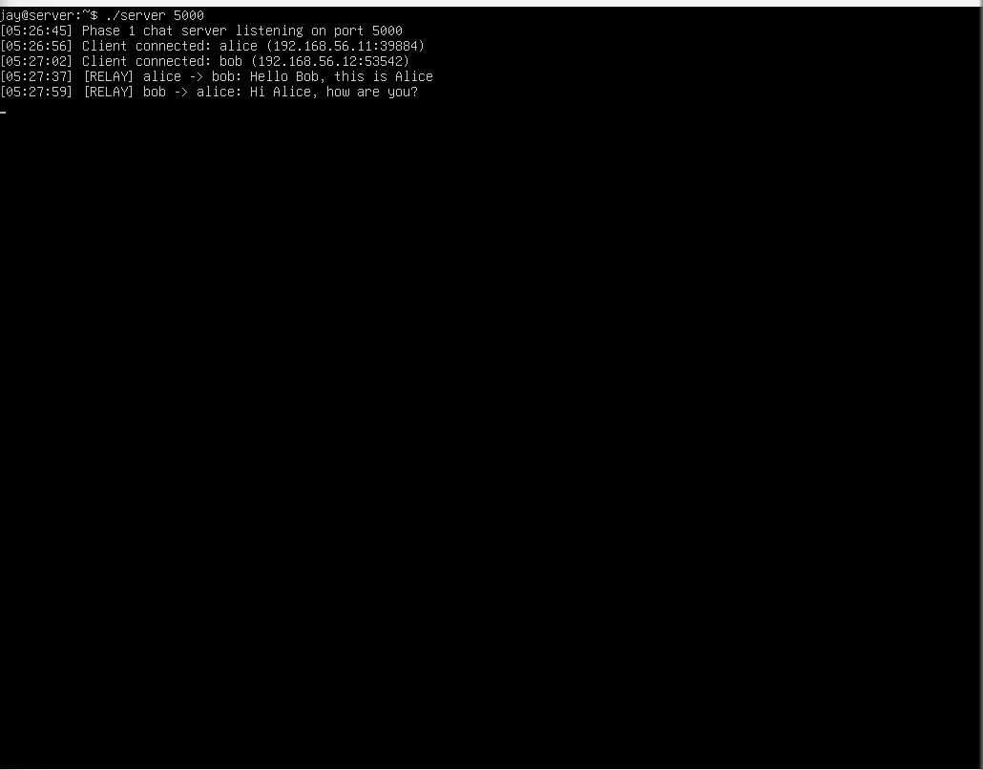
Server log showing full plaintext of every relayed message.
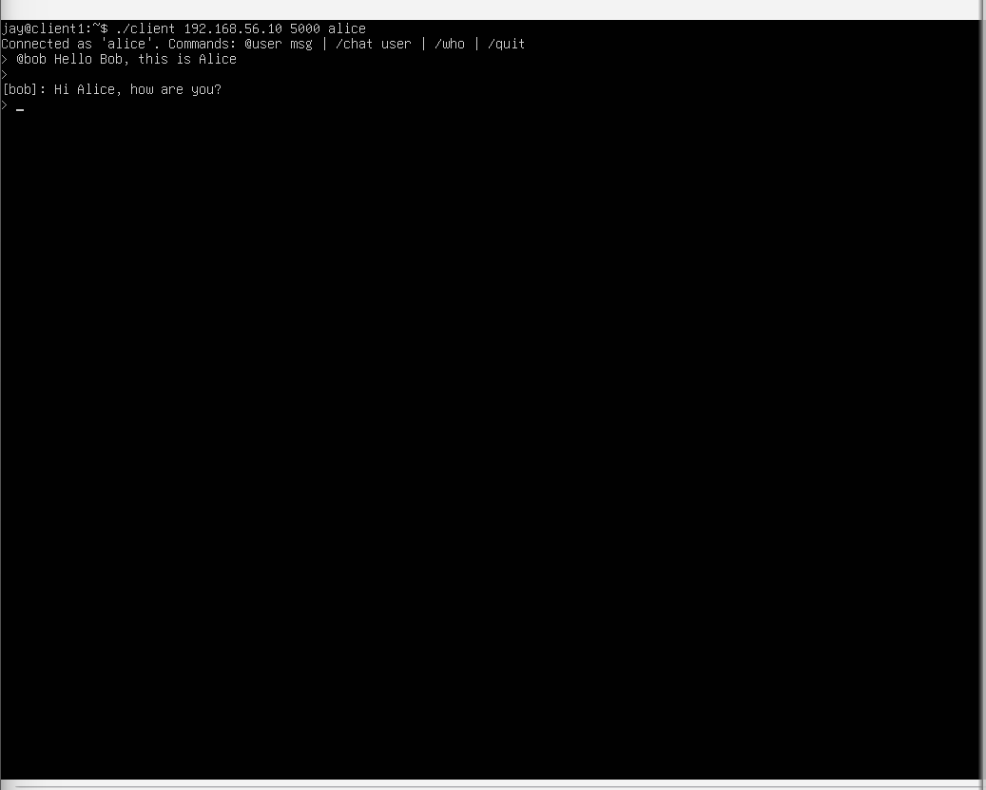
Client1 (alice) sending and receiving chat messages.
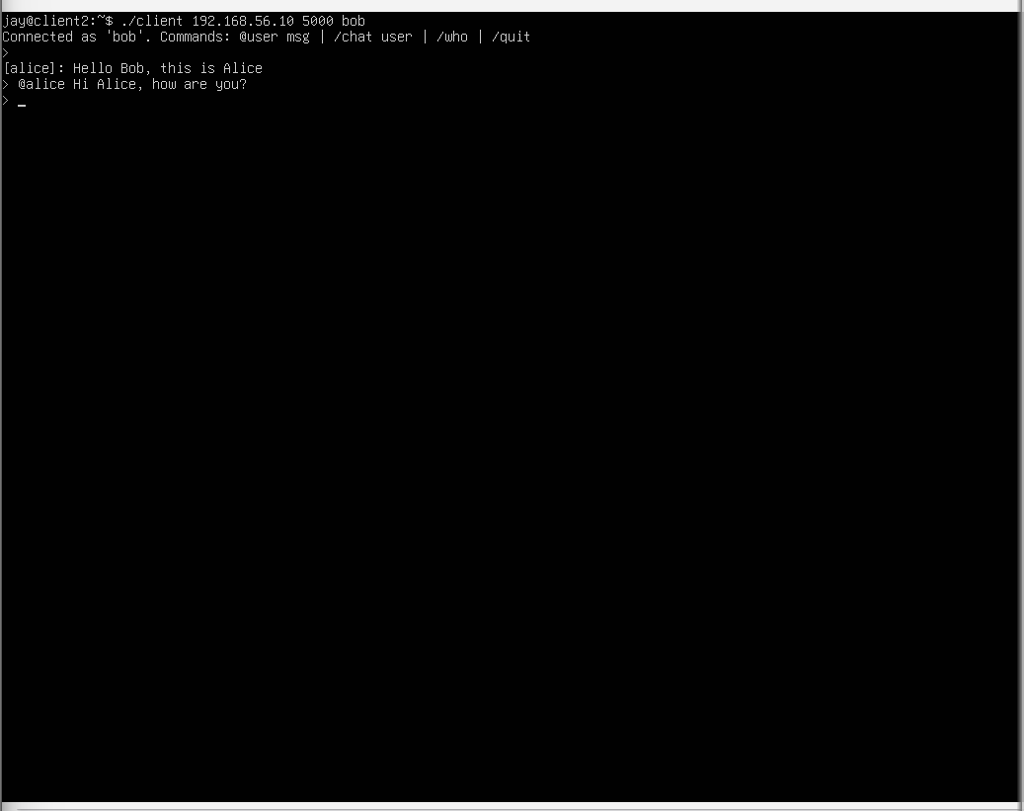
Client2 (bob) sending and receiving chat messages.

Wireshark capture
Traffic was captured on the Server VM's enp0s8 interface, filtered to tcp.port == 5000, using tcpdump. Opening the .pcap in Wireshark and using “Follow → TCP Stream” shows the username registration and all chat message content fully readable in plaintext.
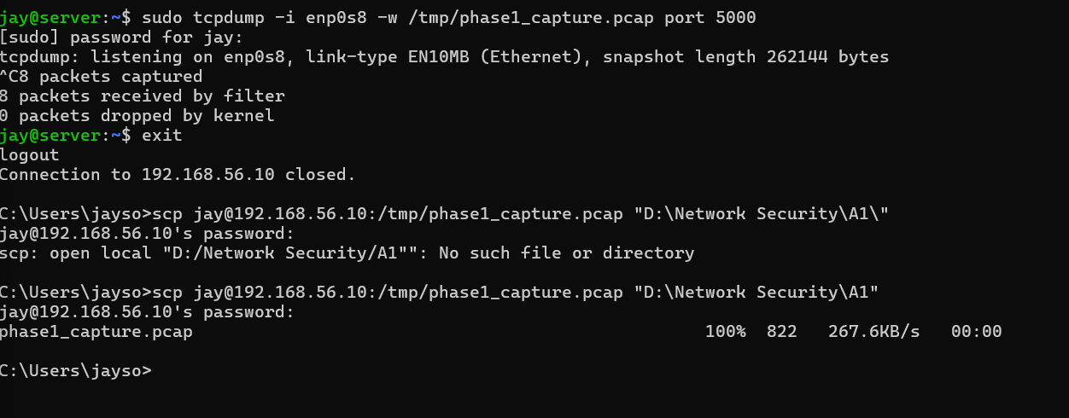
tcpdump capture command and packet count on the Server VM.
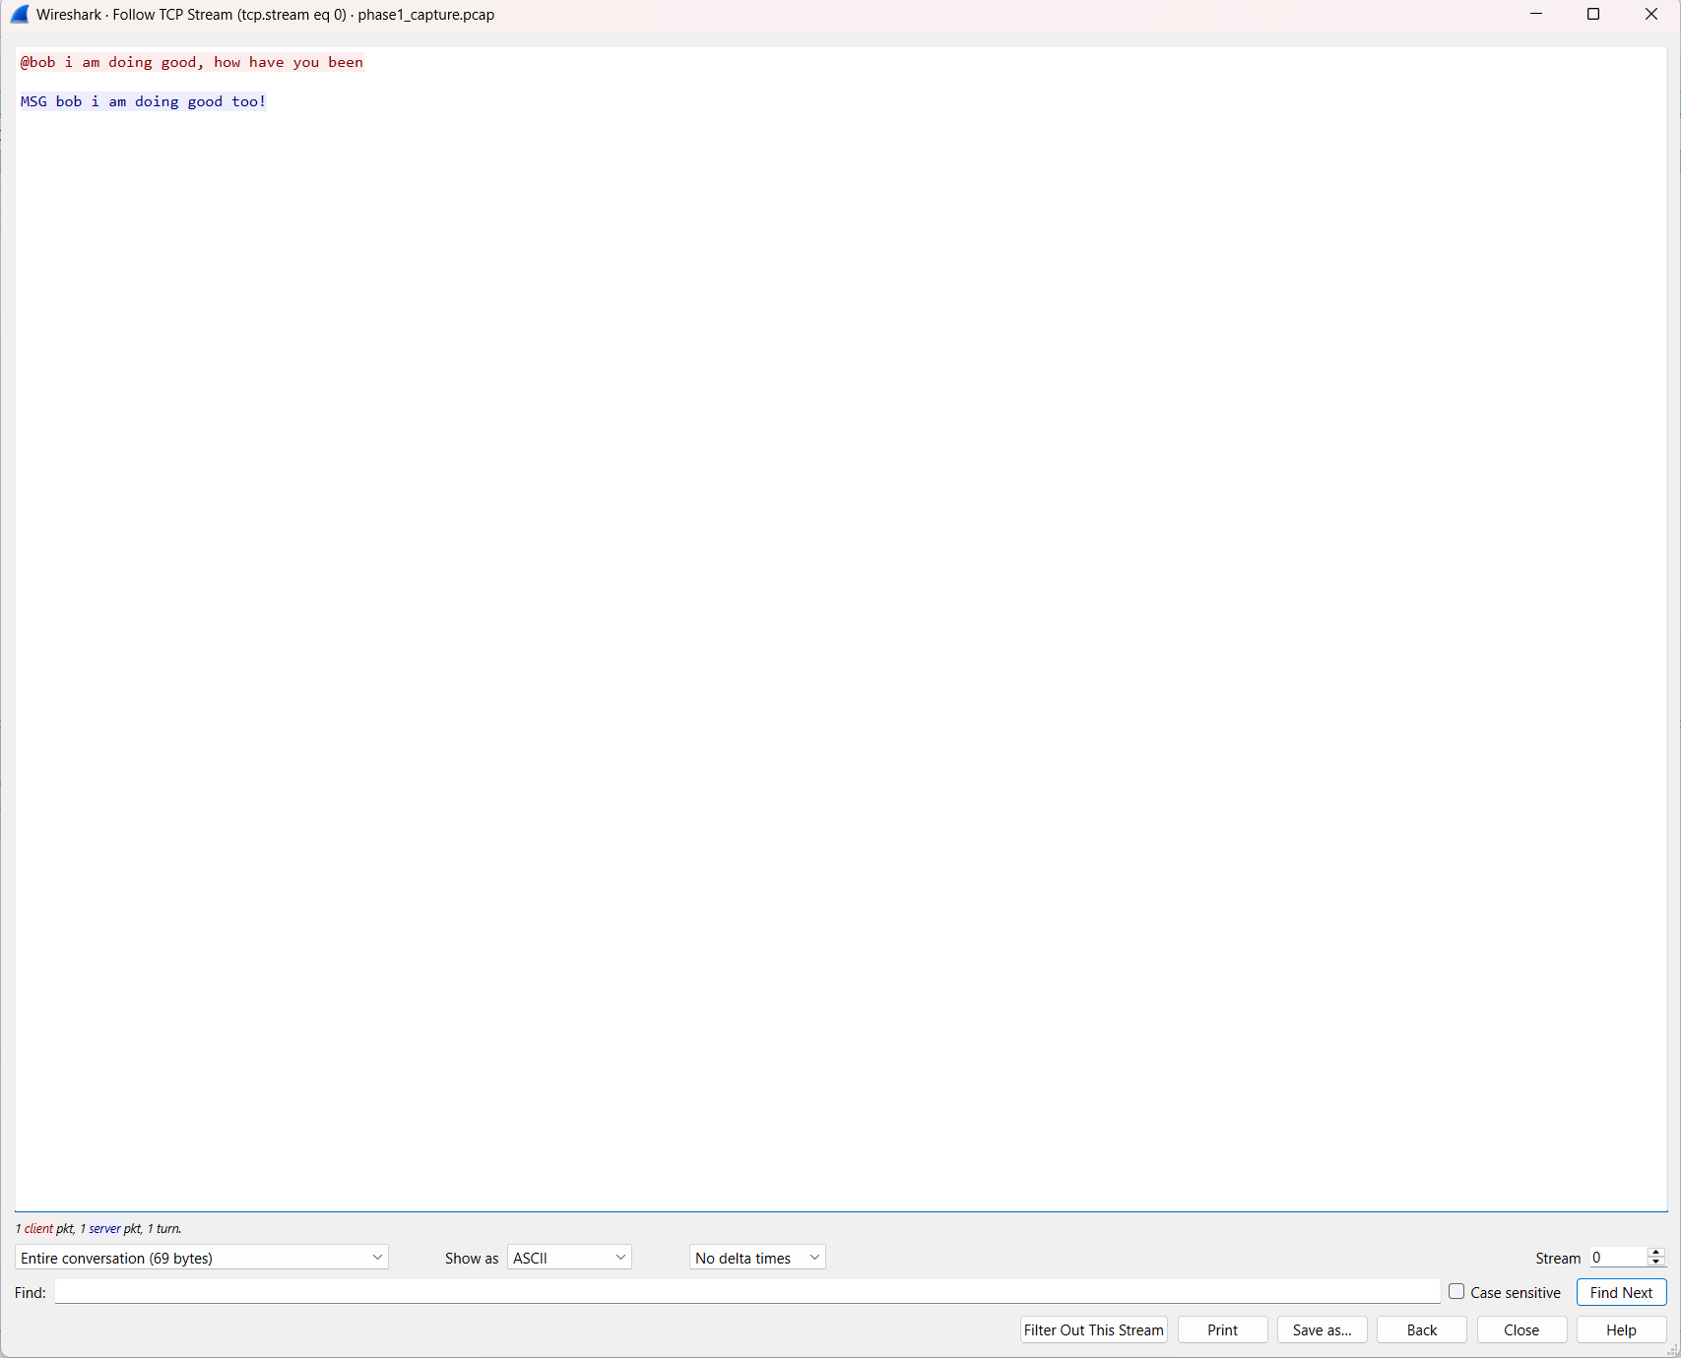
Wireshark “Follow TCP Stream” showing fully readable plaintext chat content.

Phase 2 — Client-Server Confidentiality via Diffie–Hellman

Implementation Summary
Each client independently establishes an AES-256-GCM session key with the server via a Diffie-Hellman exchange (RFC 3526 MODP Group 14, 2048-bit — verified byte-for-byte against the published RFC text before use). C1↔S and C2↔S are two entirely separate exchanges with independent random exponents; there is no shared key between C1 and C2 at this stage.

Modular exponentiation clarification (per TA guidance)
Functions with “DH” or “Diffie-Hellman” in the name (DH_generate_key, DH_compute_key, EVP_PKEY_derive used for DH, anything from <openssl/dh.h>) are disallowed, since they perform the entire exchange automatically. BN_mod_exp is a generic bignum primitive, not DH-specific, and is used directly to compute g^private mod p for both the public value and the shared secret. The DH protocol logic itself — exponent generation, exchange sequencing, and shared-secret derivation — is implemented from scratch.

Why the raw shared secret is hashed before use as a key
The raw DH output g^(ab) mod p is not uniformly distributed over the AES-256 key space — it is a number with mathematical structure inherited from modular exponentiation (certain bit patterns are more or less likely, and its distribution is not ideal for a symmetric key). Hashing it with SHA-256 (key = SHA256(shared_secret)) collapses it into a uniformly distributed, fixed-length 256-bit value — standard key-derivation practice.

Fixed-length secret encoding
The raw shared secret is converted to bytes via BN_bn2binpad with a fixed width equal to the byte-length of the prime, rather than BN_bn2bin, which can silently drop leading zero bytes. Without this, the two sides could in rare cases derive different-length “raw secret” byte strings for the same underlying value, breaking the hash-based key derivation.

AES-GCM encryption
Every message after the handshake, including username registration, is encrypted with AES-256-GCM via OpenSSL's EVP API. AES-GCM provides both confidentiality and integrity/authenticity in one primitive — a tampered ciphertext fails the authentication tag check and is rejected, rather than being silently decrypted into corrupted-but-accepted plaintext (unlike plain AES modes such as CBC).

Nonce construction
Since one DH exchange produces a single key used in both directions, nonces are tagged with a 1-byte role marker (CLIENT_TO_SERVER = 0x01, SERVER_TO_CLIENT = 0x02) followed by an 8-byte counter. This guarantees the two directions can never reuse the same nonce under the same key, even though each side's counter independently starts at 0.

Verification

Fingerprint matching
Both client and server print SHA256(SHA256(shared_secret)) — i.e., a hash of the derived key, never the raw secret or the key itself — as a “fingerprint,” for the same connection. The values matched exactly across multiple independent connections, and differed between different clients' connections, confirming the exchanges really are independent.
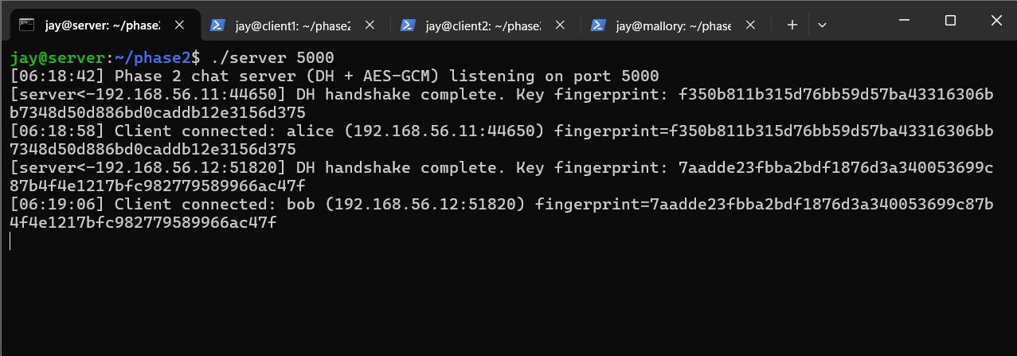
Server log showing independent DH fingerprints for alice's and bob's connections.
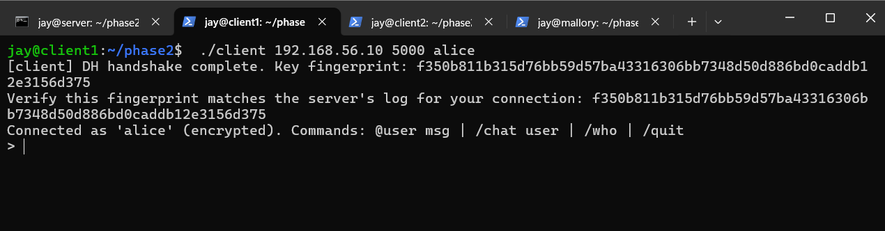
Client1's fingerprint, matching the server's log for alice's connection.
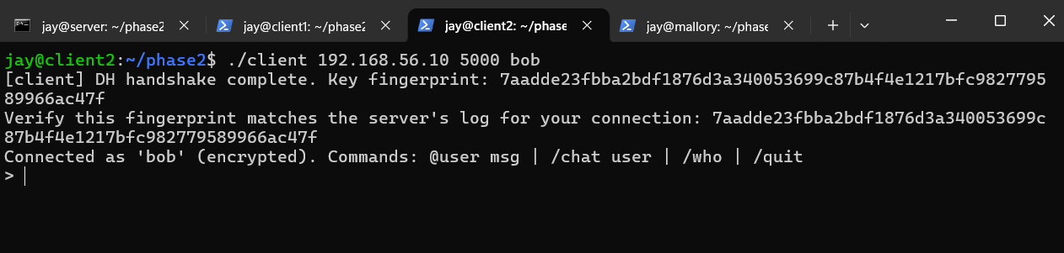
Client2's fingerprint, matching the server's log for bob's connection (a different value from alice's).
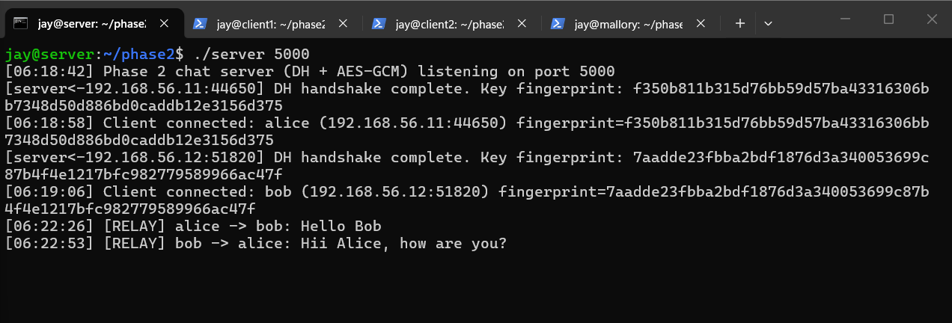
Server log showing the encrypted relay in normal operation.
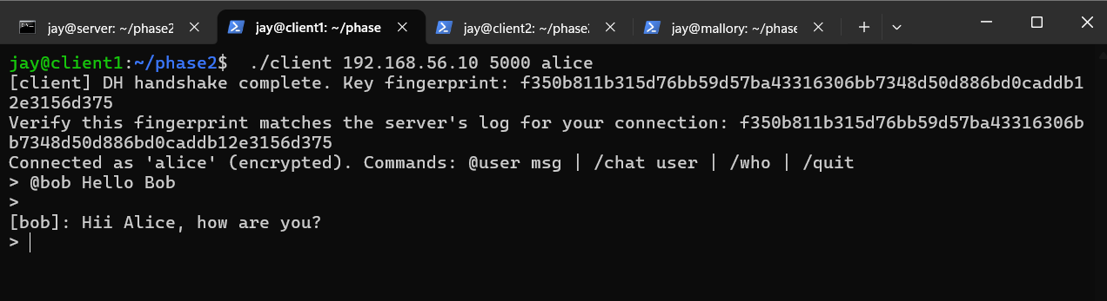
Client1 sending an encrypted message.
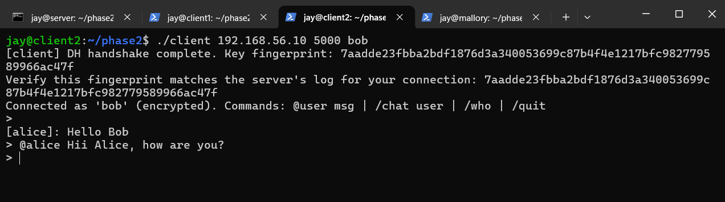
Client2 receiving the encrypted message correctly.

Wireshark re-capture
The identical capture process from Phase 1 was repeated on the same port. This time, “Follow → TCP Stream” shows only base64-encoded ciphertext — no readable usernames or message content, in direct contrast with the Phase 1 capture.
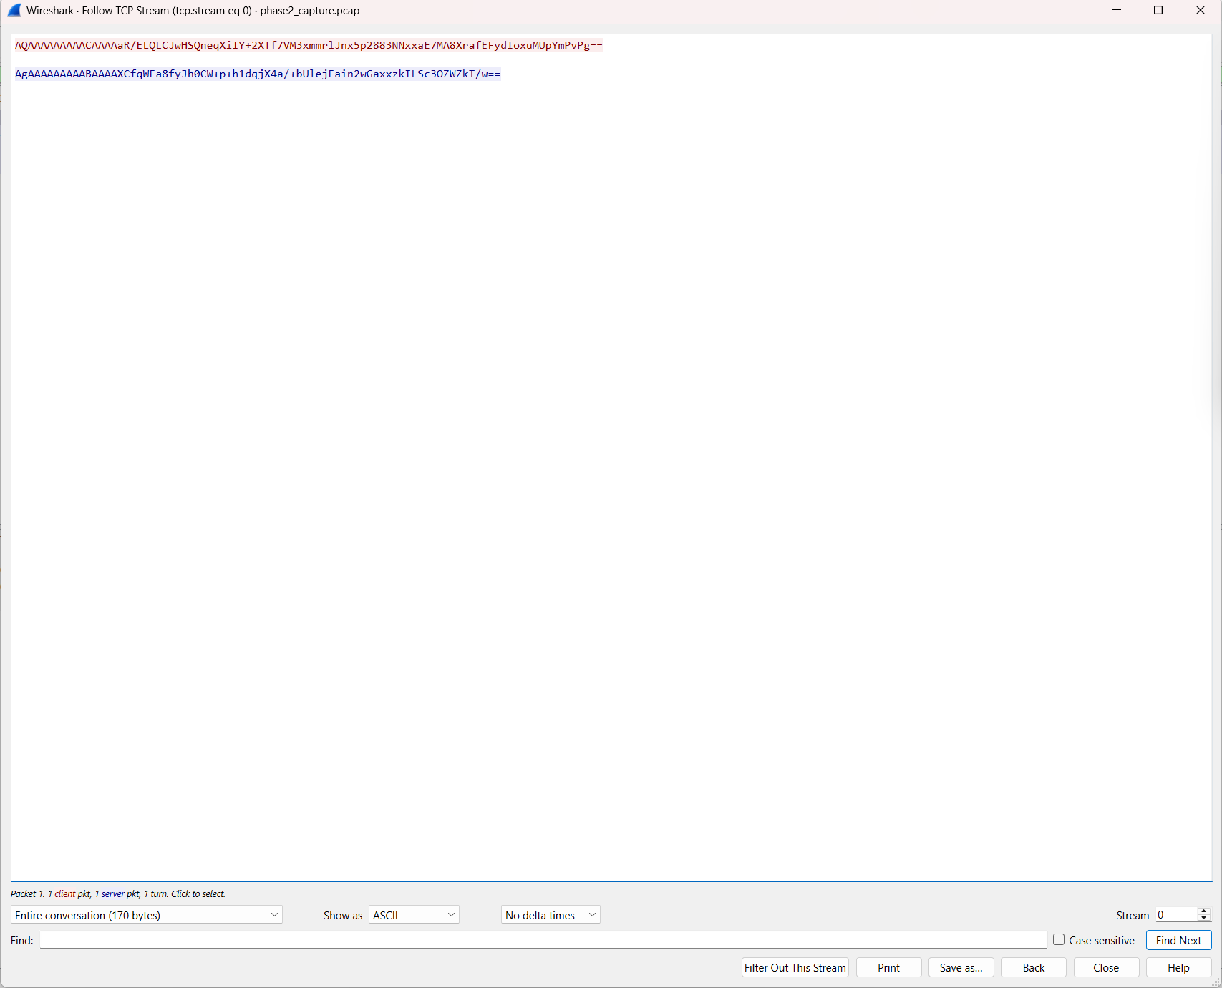
Wireshark stream showing only ciphertext — contrast directly against the Phase 1 plaintext capture.
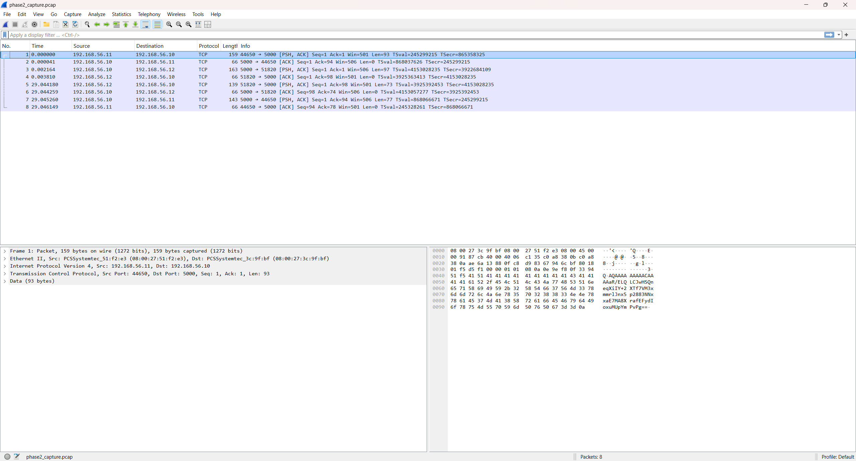
Packet list for the captured session, showing TCP segments carrying encrypted payloads.

Tamper-detection test
A standalone program (tamper_test.cpp) encrypts a sample message, decrypts the unmodified ciphertext successfully, then flips a single bit in the ciphertext and attempts decryption again. The tampered version is rejected with a GCM authentication tag mismatch — no plaintext is produced, demonstrating AES-GCM's tamper-detection property that plain AES modes lack.

MITM Attack (spec §3.3)

What was built
A proxy (mallory_proxy.cpp) run on the Mallory VM. The victim client was manually configured to connect to Mallory's IP:port instead of the real server's. Mallory performs two independent DH handshakes — one with the victim (posing as the server), one with the real server (posing as the client) — obtaining two separate session keys. It then decrypts every message from one side, logs the plaintext, re-encrypts under the other side's key, and forwards it, transparently bridging the two connections.

Result
The attack fully succeeded. The victim's client printed a fingerprint that exactly matched what Mallory computed for its victim-facing connection, so from the victim's perspective the handshake looked entirely legitimate. The real server saw a completely different fingerprint for the same username, corresponding to Mallory's server-facing connection. Mallory's log showed the full captured plaintext, including the username and every chat message, while the victim (and the innocent second client) both observed correct message delivery with no visible errors.
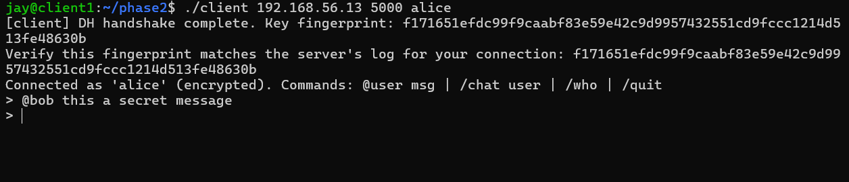
Victim's client (alice, pointed at Mallory) — fingerprint appears to check out normally from her perspective.
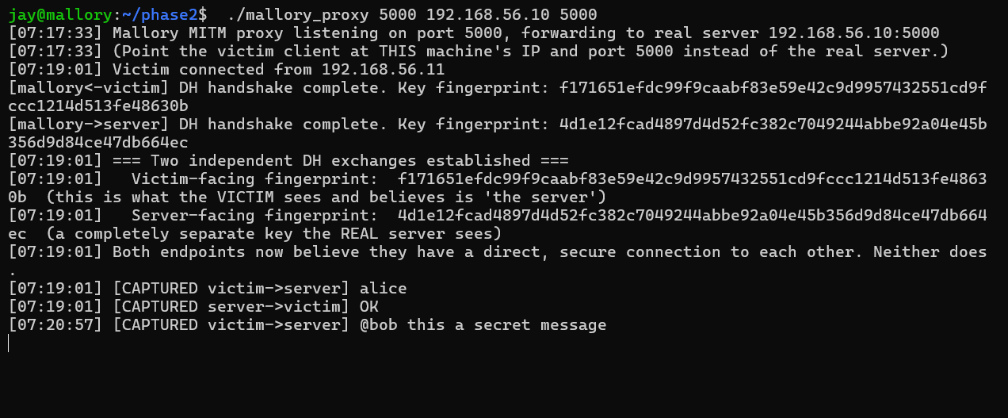
Mallory's log: two independent fingerprints (victim-facing vs. server-facing) and the captured plaintext, including the username and chat message.
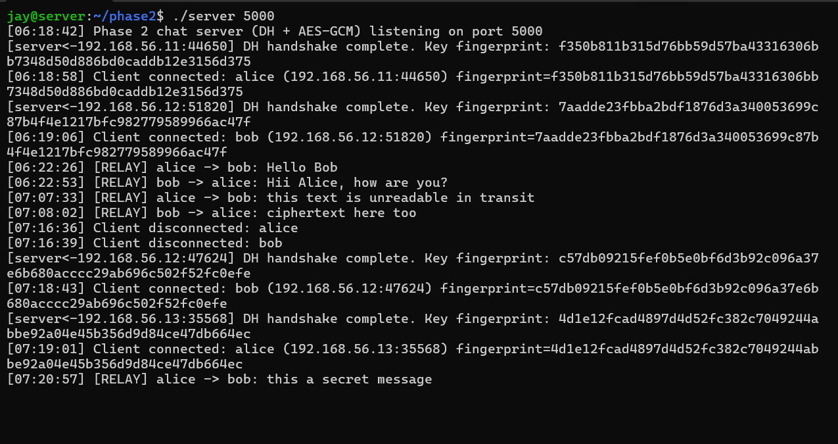
The real server's log — shows a different fingerprint for “alice” than what the victim actually saw.
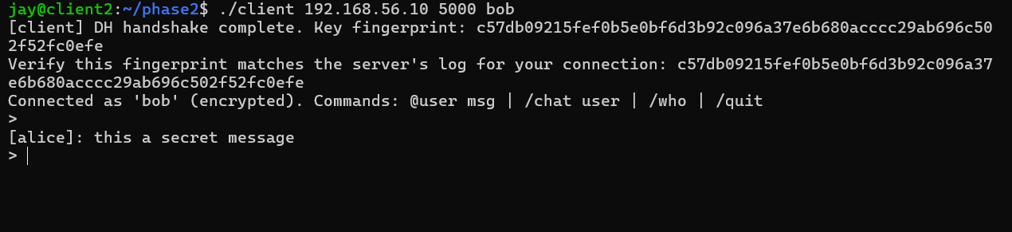
The innocent second client (bob) receiving the message correctly — the attack is fully transparent.

Why the victim could not detect this from inside the protocol
The fingerprint check the victim performed correctly matched what “the server” (actually Mallory) computed, because Mallory genuinely completed a valid DH exchange with the victim — there is no cryptographic anomaly visible from either endpoint's perspective. Diffie-Hellman only guarantees “both sides agree on a secret with whoever answered this connection”; it provides no way to verify who that is. The only way an ordinary user could catch this is out-of-band verification (e.g., reading the fingerprint aloud over a trusted side channel like a phone call), which essentially nobody does in practice. This gap is exactly what Phase 3's certificates are designed to close.

Phase 3 — Server Authentication via PKI

Implementation Summary
A minimal PKI was set up using OpenSSL's CLI: a self-signed root CA (ca.key/ca.crt), and a server certificate (server.crt) signed by that CA for identity CN=chatserver.local.

CA setup commands (from setup_ca.sh)
openssl genrsa -out ca.key 4096
openssl req -x509 -new -key ca.key -sha256 -days 3650 -out ca.crt -subj "/CN=MyChatCA"
openssl genrsa -out server.key 2048
openssl req -new -key server.key -out server.csr -subj "/CN=chatserver.local"
openssl x509 -req -in server.csr -CA ca.crt -CAkey ca.key -CAcreateserial -out server.crt -days 365 -sha256

Protocol change
Before any DH exchange, the server sends its certificate. The client validates it against its own local, trusted copy of ca.crt, checking, in order:
- Signature chains to the trusted CA — verified via X509_verify() using the CA's public key
- Validity period — via X509_cmp_current_time() on both notBefore and notAfter
- Identity (CN) matches the expected value — via X509_NAME_get_text_by_NID()
If any check fails, the client aborts immediately, sending nothing further — no nonce, no DH public value, no username.

Proof-of-possession
Even a validly-signed certificate only proves an identity was vouched for by the CA at some point in the past; it does not prove the entity on the current live connection actually controls the matching private key. After certificate validation passes, the client sends a random 16-byte nonce; the server signs it with its private key (EVP_DigestSign, RSA-SHA256); the client verifies the signature using the public key embedded in the already-validated certificate (EVP_DigestVerify). This ties “presents a valid certificate” to “is the real entity on this specific connection, right now.”
Only after both checks succeed does the Phase 2 DH handshake and encrypted chat proceed, unchanged.

Verification

Legitimate flow
Client connects, validates the certificate, completes proof-of-possession, then the DH handshake and encrypted chat proceed exactly as in Phase 2.
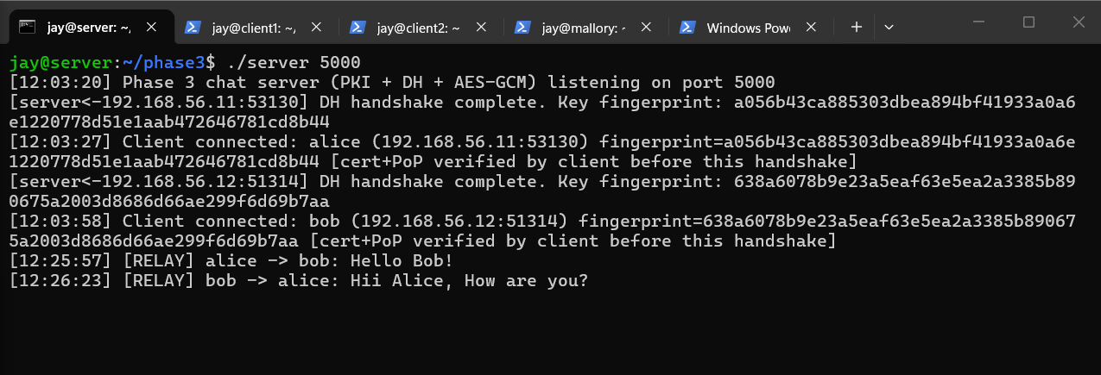
Server log: two clients connect, each after their client validated cert + proof-of-possession.
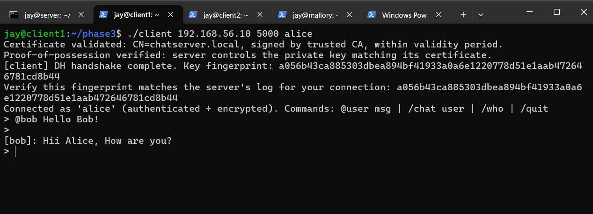
Client1 (alice): certificate validated, proof-of-possession verified, matching DH fingerprint.
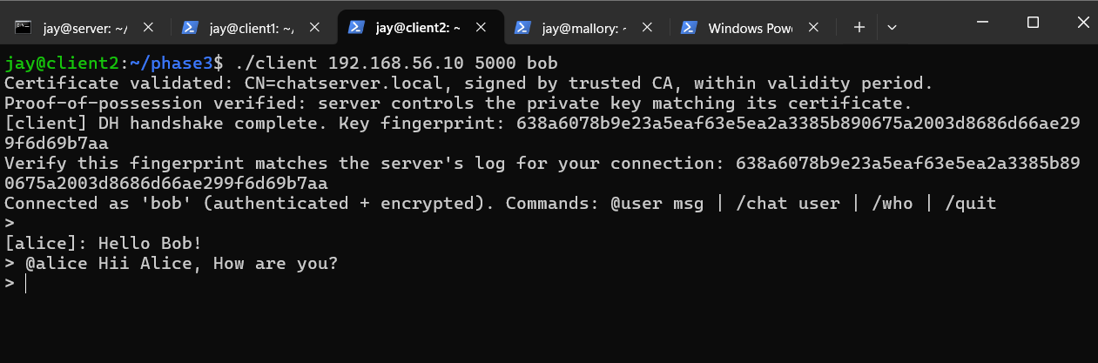
Client2 (bob): same sequence, independent fingerprint.

MITM re-attempt (spec §4.2)
The identical Phase 2 attack setup was repeated — victim pointed at Mallory. This time, Mallory could only present a self-signed certificate (mallory.crt, generated without CA involvement, using the same CN to be maximally deceptive), since it does not possess the CA's private key (ca.key). The victim's client detected that the certificate's signature does not chain to the trusted CA and aborted immediately, before sending anything further.
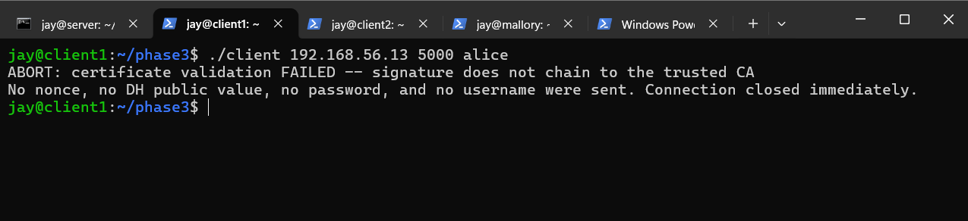
Victim's client: ABORT — certificate validation failed, signature does not chain to the trusted CA. Nothing further sent.
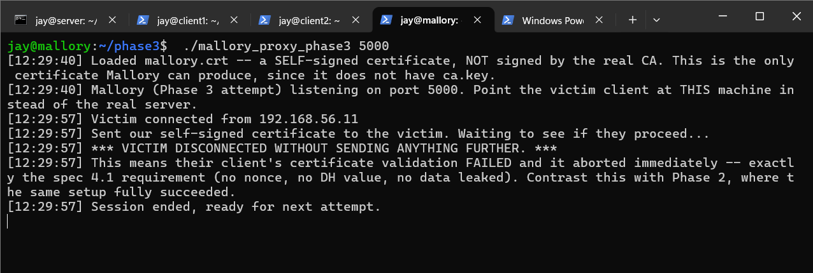
Mallory's log: victim disconnected without sending anything further — the attack fails at the very first message.
This is a direct, explicit contrast with Phase 2, where the identical setup fully succeeded — same Mallory VM, same network position, same “point the victim at the attacker” configuration, but the attack now fails at the very first message.

Stolen certificate without the private key (separate test, spec §4.2)
A distinct scenario was tested — an attacker with a copy of the genuine server.crt but not server.key (simulated via stolen_cert_attacker.cpp, which presents the real certificate but signs proof-of-possession challenges with an unrelated key). Certificate validation passed completely (it is a genuine, correctly-signed certificate), but proof-of-possession failed, since the signature did not verify against the certificate's actual embedded public key.
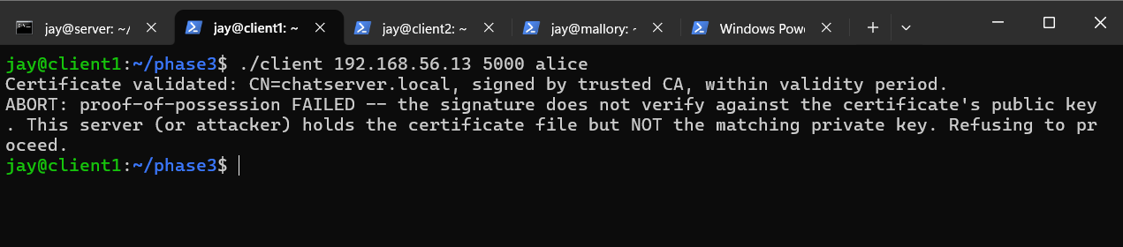
Client: certificate validated successfully, immediately followed by ABORT — proof-of-possession failed.
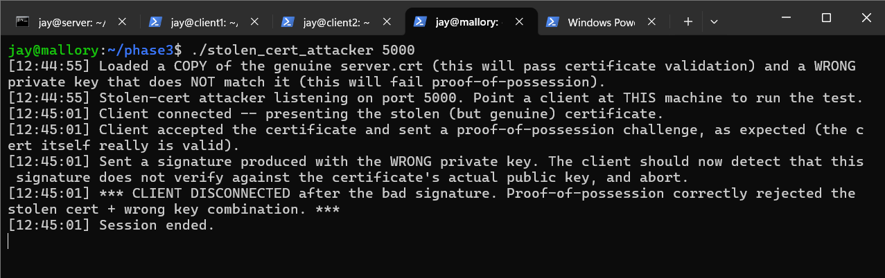
Attacker's log: presented the genuine certificate, then signed the challenge with the wrong key.
This demonstrates the two defenses catch two genuinely different attack patterns: forging your own certificate (caught by chain validation) and stealing/relaying someone else's real certificate without their private key (caught by proof-of-possession).

Note on PKI's fundamental limits (discussion point)
Phase 3 defends against an attacker who lacks the CA's private key, exactly as specified. It does not defend against a compromised or careless CA — if an attacker somehow obtained a certificate genuinely signed by the CA for the server's identity, every check described above would legitimately pass. This is an inherent property of PKI systems generally (including the one securing HTTPS across the web), not a gap specific to this implementation; real-world systems add certificate revocation and Certificate Transparency logs to mitigate this, which are outside this assignment's scope.

Phase 4 — End-to-End Encryption Between Clients

Implementation Summary
C1 and C2 establish a shared key directly with each other, independent of and never derivable by the server, triggered by the exact command /e2e username. The server's routing logic requires zero changes — phase4/server.cpp is byte-for-byte identical to Phase 3's server.

Wire tags (spec §1.4, exact strings as required)
- __E2E_INIT__<hex DH public value> — initiates (or re-initiates) the exchange
- __E2E_ACK__<hex DH public value> — completes the exchange
- __E2E_MSG__<base64 blob> — the actual encrypted chat content
These tags are just the payload of an ordinary @username-addressed message sent through the existing, already-encrypted client-server channel from Phase 3. The server's relay code (look up target, forward the payload) never inspects or understands the tag — it is opaque data as far as the server is concerned.

Layering
An E2E chat message is AES-GCM_e2e(plaintext), tagged with __E2E_MSG__, and that whole tagged string is then encrypted again via the existing Phase 3 channel::send_encrypted() call before hitting the socket — two independent AEAD layers under two independent keys, an additional inner layer rather than a replacement of the earlier links.

Nonce safety for the E2E layer
The same problem from Phase 2 applies here — one DH exchange produces a single key used by both directions. Since both usernames are known to both sides, each side deterministically assigns itself a direction byte by comparing usernames (lexicographically smaller = 0x01, larger = 0x02), guaranteeing the two directions can never collide on a nonce.

Protocol-level distinction between handshake and chat
The receiving client checks the payload's prefix before doing anything else — __E2E_INIT__/__E2E_ACK__ are fed into the DH state machine and never displayed as chat; __E2E_MSG__ is decrypted and displayed, never treated as a handshake step.

Verification

Fingerprint matching, independent of the server
Both clients print an E2E session fingerprint immediately after the exchange completes. The values matched exactly, and are computed entirely between C1 and C2 — the server never participates in or sees this computation.
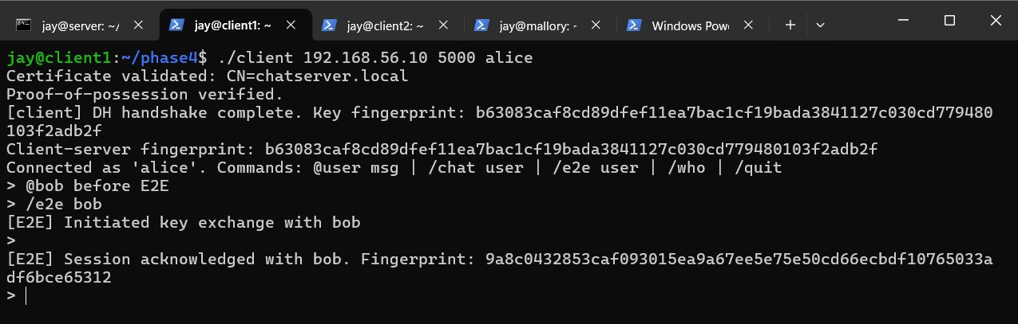
Client1 (alice): E2E session established with bob, fingerprint shown.
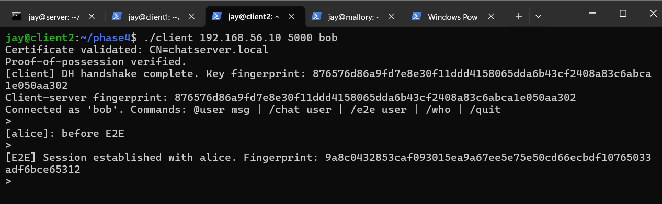
Client2 (bob): matching E2E fingerprint.

Server-blindness, before vs. after
A message was sent before /e2e (server could read it in full), then /e2e was triggered, then another message was sent. The server's log shows the plaintext message, the __E2E_INIT__/__E2E_ACK__ handshake values (public, not secret), and then the opaque __E2E_MSG__ ciphertext for all subsequent chat — both states visible together in one log.
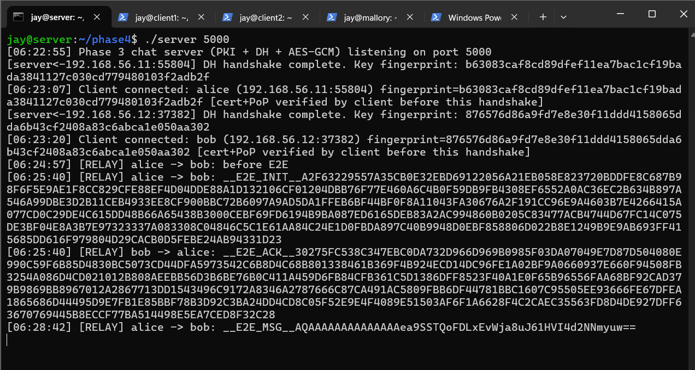
Server log: plaintext before /e2e, then opaque ciphertext after — both states in one view.

Functional correctness
The receiving client correctly displayed the decrypted message.
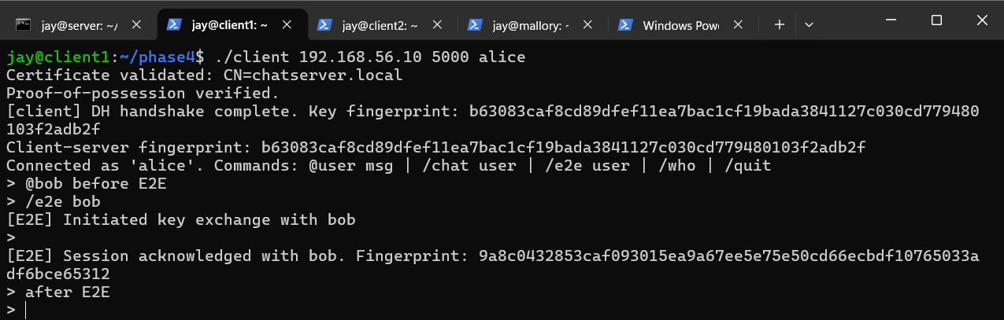
Client1: E2E message sent and received correctly.
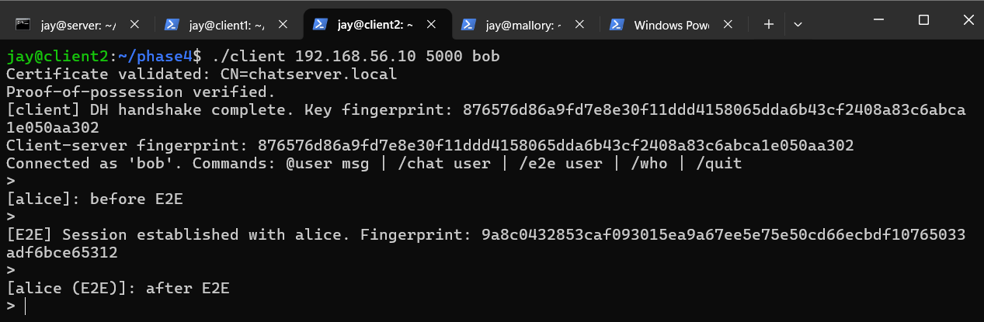
Client2: E2E message received and decrypted correctly, tagged (E2E).

Phase 5 — Forward Secrecy

Implementation Summary
The Phase 4 E2E session key is automatically renegotiated every 60 seconds, using an epoch-tagged version of the same __E2E_INIT__/__E2E_ACK__ handshake. phase5/server.cpp again requires zero changes.

Collision-avoidance design decision (spec §6.1, explicitly graded)
Both clients' 60-second timers will never fire in perfect sync. The chosen strategy is asymmetric roles: whichever username is lexicographically smaller always initiates rekeys (on its timer, or via a manual /rekey test command); the other peer never initiates on its own timer, only ever responds with __E2E_ACK__. Since there is structurally only ever one initiator for a given pair, there is no race to resolve — both sides independently compute the identical answer to “who initiates” simply by comparing the two, already-known usernames.
This was chosen over an alternative epoch/timestamp “highest proposal wins” scheme because it avoids the added complexity of detecting and resolving simultaneous proposals entirely, and is sufficient given the usernames are fixed for the session's lifetime.

Epoch tagging so in-flight messages survive a rotation
Every wire message now carries an epoch number: __E2E_INIT__<epoch>:<hex pub>, __E2E_ACK__<epoch>:<hex pub>, __E2E_MSG__<epoch>:<base64 blob>. Each session retains its current key/epoch plus the one previous key/epoch. A message tagged with the previous epoch (e.g., one that was in flight right as a rotation completed) can still be decrypted; anything older than that has already been actively destroyed.

Active key destruction
OPENSSL_cleanse() zeroes the old key's memory before it is dropped, once a new key is confirmed — “discarded” is implemented as active erasure, not merely dereferencing the old key and letting it become unreachable.

Additional documented command
/rekey username forces an immediate rotation for testing purposes, rather than waiting the full 60 seconds, per the spec's explicit allowance for extra Phase 5 commands (§1.3). It only succeeds for the lexicographically-smaller username in a pair, mirroring the automatic timer's own rule.

Verification

Fingerprint + timestamp across multiple rotations
Both clients log a timestamped fingerprint at every rotation. Across two consecutive rotations (epoch 0 → 1 → 2), the fingerprint changed each time, and both clients agreed on the identical value after each rotation completed.
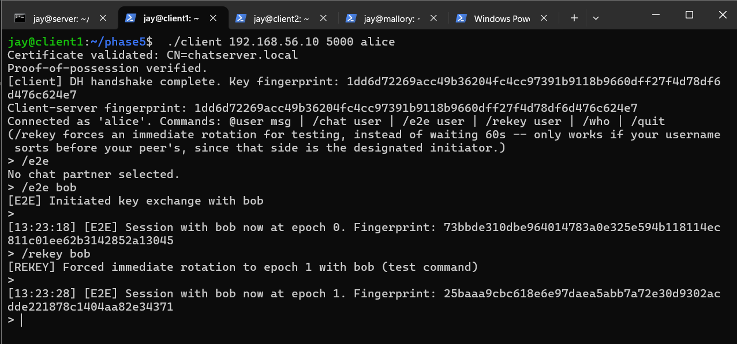
Client1: E2E session established (epoch 0), then rotated to epoch 1 via /rekey — new fingerprint, timestamped.
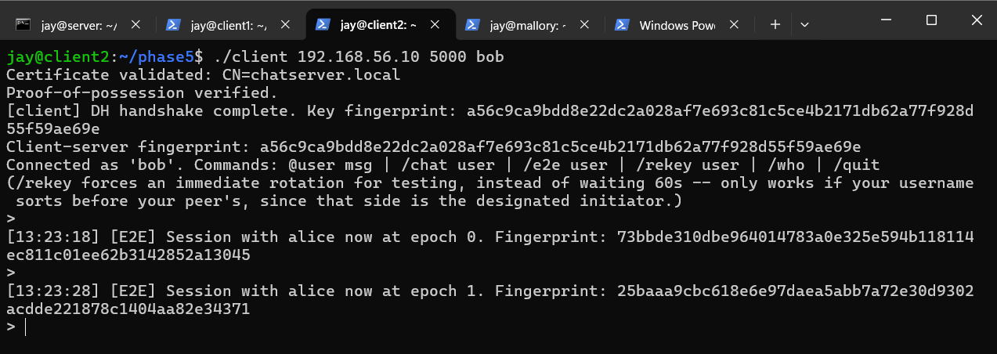
Client2: matching epoch 0 and epoch 1 fingerprints.
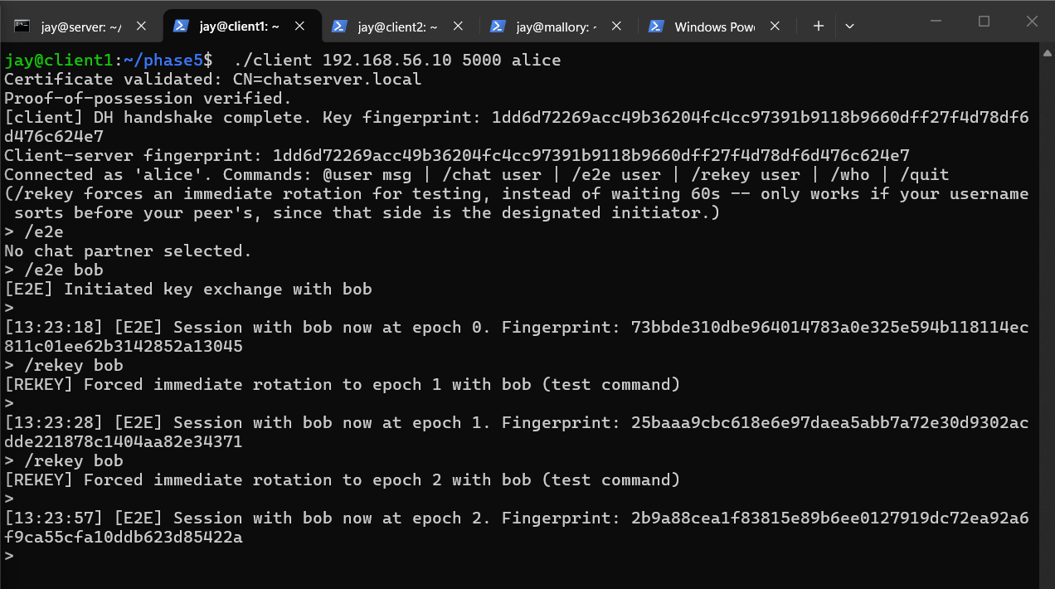
Client1: continuing to epoch 2 — a third, different fingerprint, timestamped.
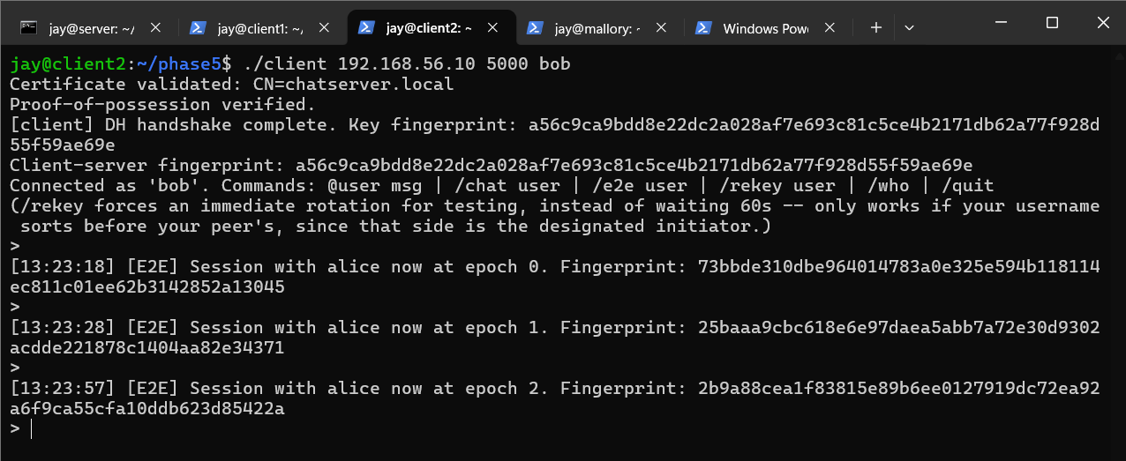
Client2: matching epoch 2 fingerprint.

Post-rotation message delivery
A message sent immediately after a rotation completed was correctly decrypted by the recipient, displayed with its epoch tag, confirming the rotation did not disrupt the live session.
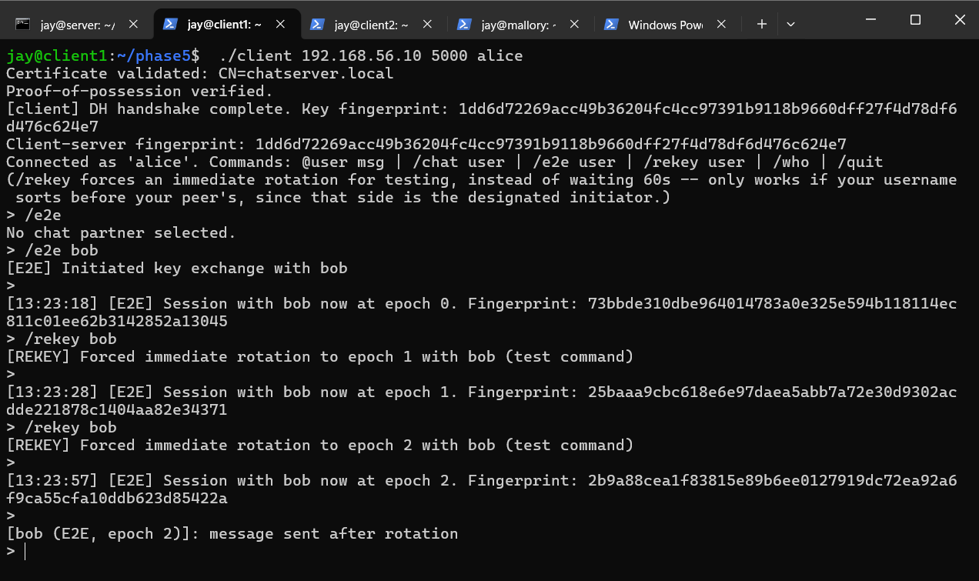
Client1: message sent after rotation, tagged with the current epoch, delivered correctly.
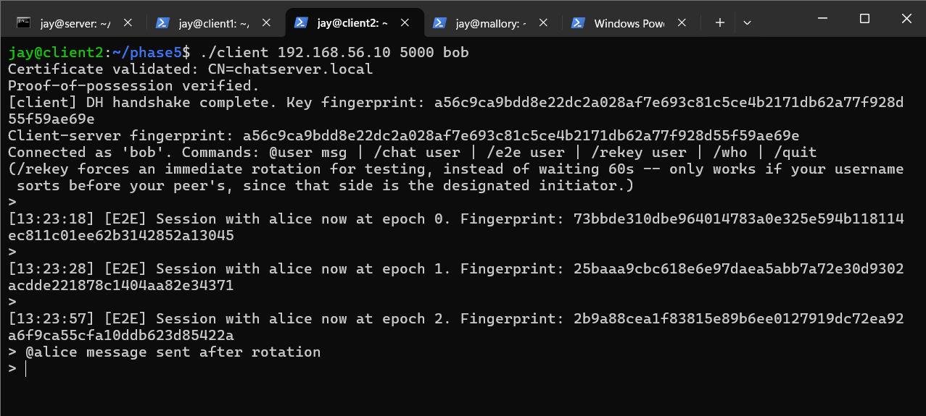
Client2: correctly received and decrypted the post-rotation message.

Written Explanation (spec §6.2, explicitly graded)

What forward secrecy actually buys you
In Phase 4 alone, C1 and C2 use one static E2E session key for the entire conversation. If an attacker later compromises that single key — say, by seizing a device or exploiting a bug — and had been logging the encrypted traffic throughout, they can decrypt every message from the entire session, past and future, since it was all protected by the same unchanging key.
With Phase 5's rotation, each ~60-second window uses a fresh key derived from a brand-new, independent DH exchange (not derived from the old key). Once a window ends, that window's key is actively erased from memory.
Concretely: if an attacker compromises the key active during, say, minute 5 of a conversation, they can decrypt only the traffic sent during that ~60-second window. They cannot decrypt earlier traffic (minutes 0–4), because those windows' keys were independently derived and have already been destroyed — there is no mathematical path from the minute-5 key back to an earlier one. They also cannot decrypt later traffic (minute 6 onward) without separately compromising each subsequent key, since future keys come from fresh DH exchanges the attacker was not part of.
What forward secrecy does not protect against: an attacker with ongoing, continuous access to a compromised endpoint (e.g., malware actively running in memory during every rotation) could still capture each new key as it is generated. Forward secrecy specifically limits the blast radius of a single, later, point-in-time compromise of previously-discarded key material — it does not make an actively-controlled endpoint secure.
This is the concrete contrast with Phase 4: one static key there means one compromise exposes the whole conversation. Here, one compromise exposes only one ~60-second window, and the size of that window is a direct, tunable security/latency tradeoff.

Appendix A — Generative AI Usage
Per spec §1.5, every LLM prompt used across this assignment is listed here in full.
Prompt 1: "How do I implement a non-blocking line reader in C++ using raw sockets for a TCP chat server?"

Prompt 2: "What is the correct OpenSSL EVP API sequence for AES-256-GCM encryption and decryption in C++, including authentication tag verification?"

Prompt 3: "How can I use OpenSSL BN functions to perform modular exponentiation for a custom Diffie-Hellman implementation without using deprecated DH APIs?"

Prompt 4: "What are the exact X509 API functions in OpenSSL to verify a certificate signature against a trusted CA certificate and check its validity dates?"
Prompt 5: "How do I implement automated 60-second key rotation with epoch tagging for end-to-end encrypted chat sessions in C++?"
Prompt 6: "What are the correct syntax and best practices for utilizing OPENSSL_cleanse() to safely zero out expired session keys from memory during rekeying events?"
Prompt 7: "How can I structure a netplan configuration file across multiple Ubuntu 24.04 virtual machines to maintain a static isolated host-only network without DHCP conflicts?"

Appendix B — Codebase Artifacts & Compilation Guide
- Server Implementation (server.cpp): Manages the multi-client TCP socket loop, newline-delimited message framing, and username mapping across all implementation phases.
- Client Implementation (client.cpp): Handles interactive command parsing for chat interfaces (@username, /chat, /e2e, /rekey) and manages stacked cryptographic layers.
- Attacker Tooling (mallory_proxy.cpp): Custom proxy script utilized for demonstrating Man-in-the-Middle vulnerabilities during Phase 2 and verifying certificate validation controls in Phase 3.
- Build Requirements: Applications are compiled using g++ -std=c++17 linked explicitly against OpenSSL libraries (-lssl -lcrypto) for Diffie-Hellman, AES-256-GCM, and X.509 parsing.

